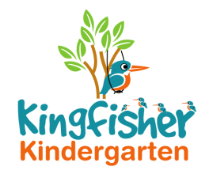
Care, Learning and Play Policy

Children learn when they are in a safe and caring environment where they are stimulated through play.

Children develop best when they are in a caring relationship with an adult. A baby will learn to walk faster when they have a safe pair of arms to walk towards and learn to talk, when they have an adult listening and responding to them.

We will strive to provide your child with an environment that will be caring, fun and stimulating. We will implement ideas from the Early Years Foundation Stage and includes:

CL - Communication and Language.
EAD - Expressive Arts and Design
L - Literacy
M - Mathematics
PD - Physical Development
PSED - Personal, Social and Emotional Development
UW - Understanding the World

Please see our Early Years Foundation Stage Policy for more information.

These activities will include but are not limited to:
- Dressing up clothes.
- Books.
- Small world toys.
- Construction toys (Lego, Duplo etc).
- Pretend play (toy kitchen etc).
- Water play.
- Arts and Crafts,
- Cooking.
- Gardening.
- Outdoor play and equipment.

We will regularly observe your child and make records, these will enable us to make plans on how we can help your child move onto the next stage of their development.

If there is a particular activity that you would like us to do with your child, please let us know. We are very happy to support activities that you are doing at home or events that have happened. For example if you have been to a wedding we can continue this theme by providing the children with material to use as wedding clothes and help them understand through books and other resources.

This policy was adopted by Kingfisher Kindergarten Ltd
on 22nd January 2019
Date to be reviewed Annually
Signed on behalf of the provider La-Ryne Baker
Role of signatory Owner

