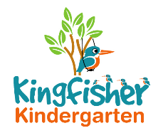
Lunch Club Policy

We offer Lunch Club every day from 11.30am to 12.30pm, which is supervised members of staff, at least one of whom is NVQ level 3 or equivalent. All staff have first aid training and all staff understand the Health and Hygiene Policy for our setting.

At the start of lunch club all children will be supervised and encouraged to go to the toilet and wash their hands prior to starting their lunch. The children then eat their packed lunch around the tables with the staff.

We ask parents/carers to pack lunch with ice blocks on sunny days as the lunch boxes stay in a cool place until lunch time.

We advise parents/carers of a healthy lunch, with fruit such as grapes, tomatoes etc chopped up ready for the child to eat and to avoid them being a choking hazard. We ask all parents/carers not to pack any peanut-related food due to allergies.

After lunch children have an opportunity to play/have quiet time before being picked up or staying for the afternoon session.

Snack time
We serve healthy snacks, that each child brings into a pre-school session. We offer milk and water and each child brings a drinks bottle with water in for a drink during session time.

This policy was adopted by Kingfisher Kindergarten Ltd

Date to be reviewed Annually
Signed on behalf of the provider La-Ryne van der Westhuizen
Role of signatory Owner

