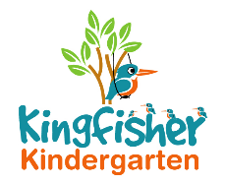
Supervision of Children on Outings
and Visits Policy

When we have planned outings, parents will be asked to sign an agreement (or disagreement) regarding their child taking a part in that particular activity/outing.

We will always ensure on any activity day, that we are well within ratio and we will be asking parents for assistance to fulfil the ratio if this cannot be met by staff. If we cannot meet the ratio, the activity/outing will not go ahead.

The parents will be given adequate notice regarding our outings.

If the trip is long distance, visiting site etc., the parents/carers will be expected to take their own child/ren.

The staff will only look after the children, whose parents cannot attend for an exceptional reason. The member of staff has to agree to this her/himself. Extra written permission will be required from the parents/carers.

The following items will have to be taken to every outing:
- First Aid box (any important medication – allergies/inhalers)
- Bottle of drinking water
- Medical list of children taking part
- Complete Contact list, including emergency details for children and staff
- Register for both children and parent helpers/volunteers
- Mobile phone

This policy was adopted by Kingfisher Kindergarten Ltd

On 22nd January 2019
Date to be reviewed Annually
Signed on behalf of the provider La-Ryne Baker
Role of signatory Owner

