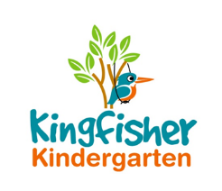
Progress Report at Age 2 Policy

Early Years Foundation Stage 2012 requires that we supply parents/carers with a short summary of their child’s development in the three prime learning and development areas.

There are:
- Personal social and emotional development
- Physical development
- Communication and language

This will be completed within the child’s first term at Kingfisher Kindergarten and when the child is aged between 24 and 36 months.

This policy was adopted by Kingfisher Kindergarten Ltd

On 22nd January 2019

Date to be reviewed Annually

Signed on behalf of the provider La-Ryne Baker

Role of signatory Owner

